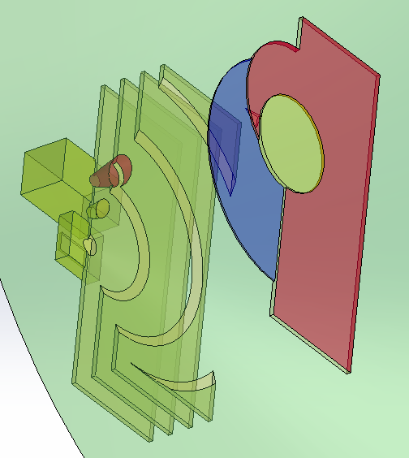

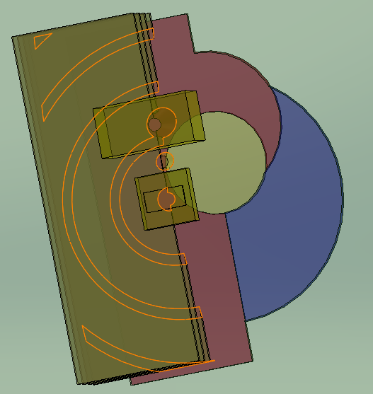

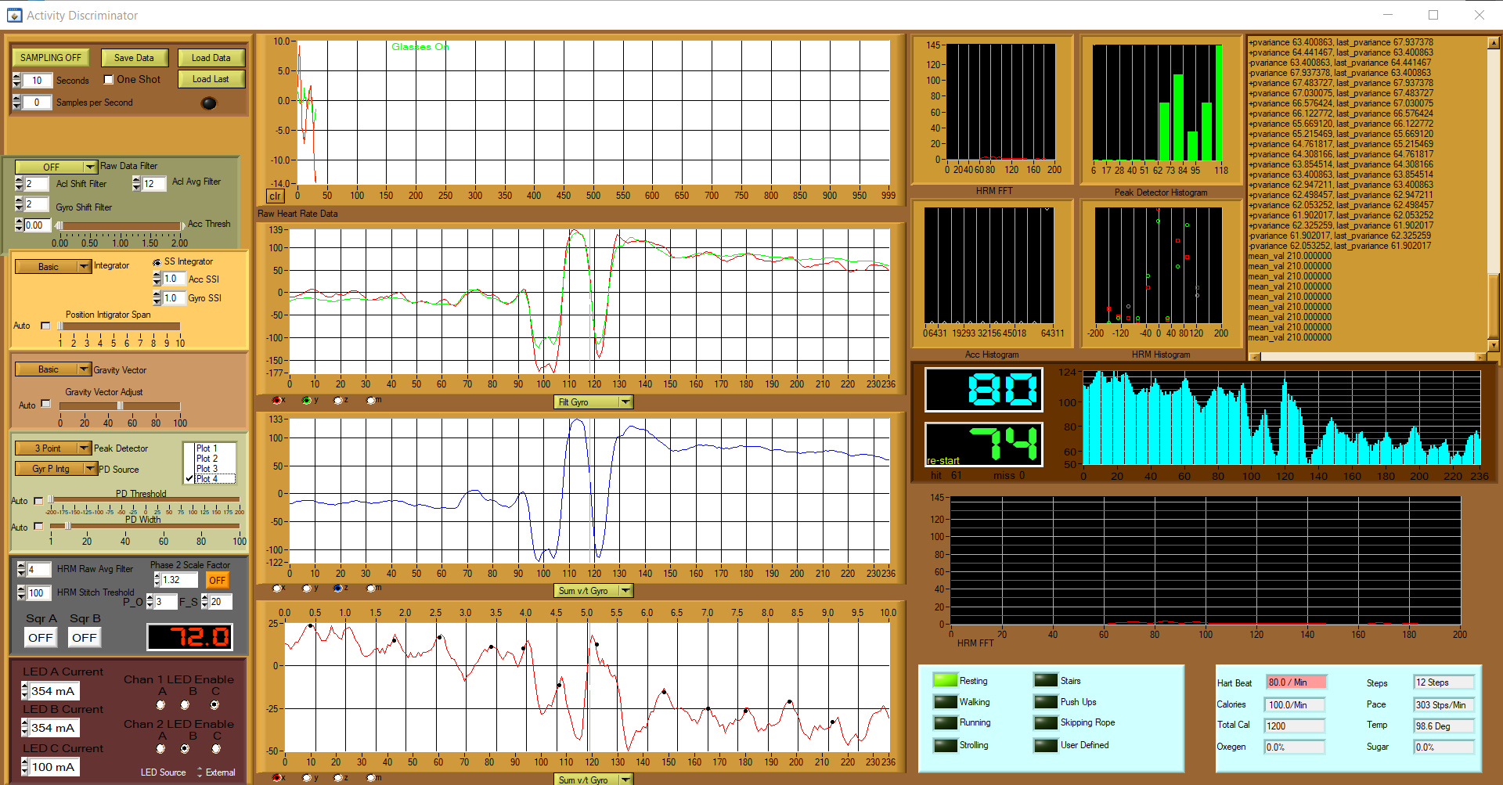

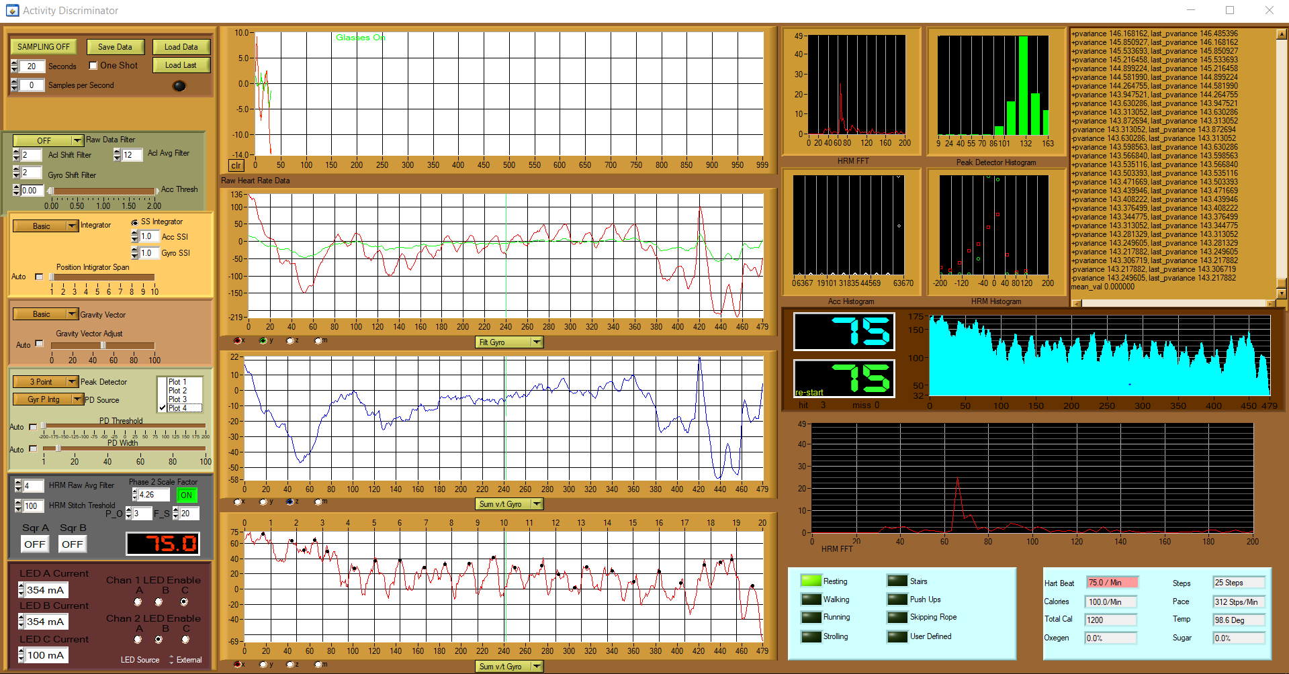
HRM Glasses:

static const char m_target_periph_name1[] = "Level 19B1"; // small
static const char m_target_periph_name2[] = "Level 6DA7"; // old wide
static const char m_target_periph_name3[] = "Level CFA7"; // new wide

Primary Service:
0x180A
Batt Service:
0x180F
UART Service:
6E400001-B5A3-F393-E0A9-E50E24DCCA9E

FW:
#define DEVICE_NAME "Level" /**< Name of device. Will be included in the advertising data. */
#define MANUFACTURER_NAME "TheShop" /**< Manufacturer. Will be passed to Device Information Service. */
#define MODEL_NUM "678" /**< Model number. Will be passed to Device Information Service. */
#define FW_REV_MAJOR 3
#define FW_REV_MINOR 45 /**< errata 20 implemented as possible fix for occassional sys_timer startup problems*/
#define MANUFACTURER_ID 0x1122334455 /**< Manufacturer ID, part of System ID. Will be passed to Device Information Service. */
#define ORG_UNIQUE_ID 0x667788
HRM_PKT = 0x69

HRM communications:
The sensor data is a constantly steaming series of 11 bytes in the following order:
0 0x69 Sync Byte
1 H byte AX
2 L byte AX
3 H byte AY
4 L byte AY
5 H byte AZ
6 L byte AZ
7 H byte Rear sensor Chan 1
8 L byte Rear sensor Chan 1
9 H byte Rear sensor Chan 2
10 L byte Rear sensor Chan 2
11 0 -> 255 Pkt #

Control is open loop one byte unsigned char command (ASCII encoded) followed by a data unsigned byte 0-255:
"a" and "b" are internal and external LED enables. DO NOT USE

"c" + led enable chan1
"d" + led enable chan2
0x01 = LED A = narrow or rear LED near
0x04 = LED B = wide or foward LED
0x02 = LED C = narrow or rear LED far

"e" + current chan A
"f" + current chan B
“g” + current chan C
The LED current is table driven with values as follow:
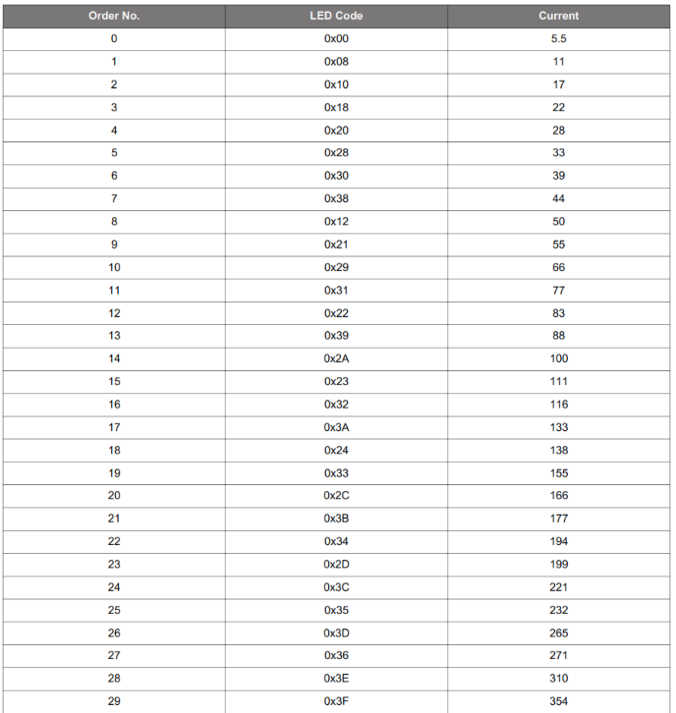

1153 control code on the ‘52:

void hrm_read_cmd(void)
{
int time_out = 0;
int t_o = 100;

if(uart_rx_ubyte != 0x00)
{
if(uart_rx_ubyte == 0x61) // a = internal led
{
SetIRLEDAnode(1);
}
if(uart_rx_ubyte == 0x62) // b = external led
{
SetIRLEDAnode(0);
}

if(uart_rx_ubyte == 0x63) // c = led enable chan1
{
SetIRLEDAnode(1);
while((uart_rx_ubyte == 0x63) && (time_out < t_o)){nrf_delay_ms(10); time_out++;}
if(time_out < t_o)
{
Si115xParamSet(PARAM_MEASCONFIG0, uart_rx_ubyte);
nrf_delay_ms(100);
SetIRLEDAnode(0);
}
}

if(uart_rx_ubyte == 0x64) // d = led enable chan2
{
SetIRLEDAnode(1);
while((uart_rx_ubyte == 0x64) && (time_out < t_o)){nrf_delay_ms(10); time_out++;}
if(time_out < t_o)
{
Si115xParamSet(PARAM_MEASCONFIG1, uart_rx_ubyte);/// + 0x08);
nrf_delay_ms(100);
SetIRLEDAnode(0);
}
}

if(uart_rx_ubyte == 0x65) // e = current chan1
{
SetIRLEDAnode(1);
while((uart_rx_ubyte == 0x65) && (time_out < t_o)){nrf_delay_ms(10); time_out++;}
if(time_out < t_o)
{
Si115xParamSet(PARAM_LED1_A, uart_rx_ubyte);
Si115xParamSet(PARAM_LED1_B, uart_rx_ubyte);
nrf_delay_ms(100);
SetIRLEDAnode(0);
}
}

if(uart_rx_ubyte == 0x66) // f = current chan 2
{
SetIRLEDAnode(1);
while((uart_rx_ubyte == 0x66) && (time_out < t_o)){nrf_delay_ms(10); time_out++;}
if(time_out < t_o)
{
Si115xParamSet(PARAM_LED2_A, uart_rx_ubyte);
Si115xParamSet(PARAM_LED2_B, uart_rx_ubyte);
nrf_delay_ms(100);
SetIRLEDAnode(0);
}
}

if(uart_rx_ubyte == 0x67) // g = current chan 3
{
SetIRLEDAnode(1);
while((uart_rx_ubyte == 0x67) && (time_out < t_o)){nrf_delay_ms(10); time_out++;}
if(time_out < t_o)
{
Si115xParamSet(PARAM_LED3_A, uart_rx_ubyte);
Si115xParamSet(PARAM_LED3_B, uart_rx_ubyte);
nrf_delay_ms(100);
SetIRLEDAnode(0);
}
}
uart_rx_ubyte = 0x00;
}
}

Get SI115x_REG_HOSTOUT1,2,4,5
Left hand averaging (4)
Check for limit and stitch
AGC laser control
SI115x_REG_COMMAND, 0x11; // Force cmd
hrm_read_cmd();
Hang around post processing data for 50 msec

Get SI115x_REG_HOSTOUT1,2,4,5
Left hand averaging (4)
Check for limit and stitch
AGC laser control
SI115x_REG_COMMAND, 0x11; // Force cmd
hrm_read_cmd();
Hang around post processing data for 50 msec
P2P scale and subtract chan 2 from chan 1 reiteration
Peak detect
Average last n pulse rates
Send to BLE

